M.S.SANJAY

15BCE0517

EXPERIMENT 3

> plotdata=c(weather$RAIN)

> barplot(plotdata,main="Rainfall",ylab="Rainfall",names.arg=1:365,legend=rownames(plotdata))

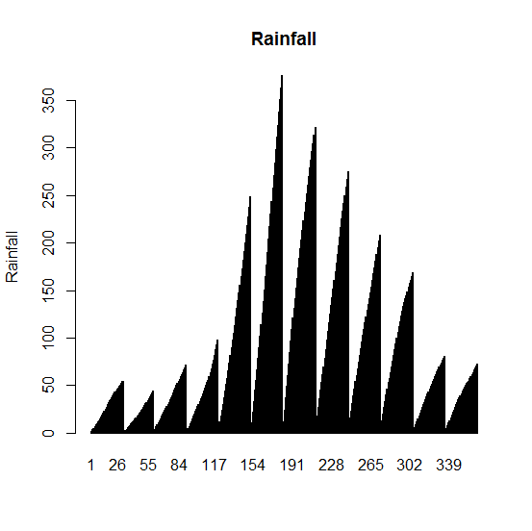

> plotdata=c(weather$RAIN[30:50])

> barplot(plotdata,xlab="days 30 to 50",ylab="Rainfall in cm",col="red",main="Rainfall for days 30 to 50-M.S.Sanjay 15bce0517",names.arg=30:50)

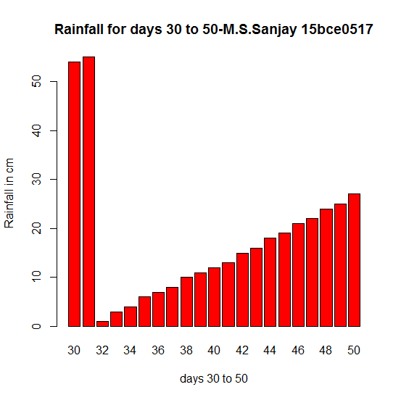

> data=weather$RAIN

> x=c(sum(data[1:31]),sum(data[32:59]),sum(data[60:90]),sum(data[91:120]),sum(data[121:151]),sum(data[152:181]),sum(data[182:212]),sum(data[213:243]),sum(data[244:273]),sum(data[274:304]),sum(data[305:335]),sum(data[336:365]))

> x

[1] 897 588 1114 1296 3657 5636 5508 4431 3323 2969 1321 1231

> pie(x,c('january','february','march','april','may','june','july','august','september','october','november','december'),main="monthly rainfall")

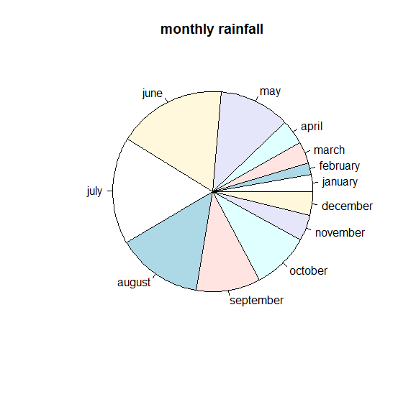

> plot(c(1,2,3,4,5,6,7,8,9,10,11,12),x,main="monthly rainfall -m.s.sanjay 15bce0517",xlab="months",ylab="rainfall in cm")

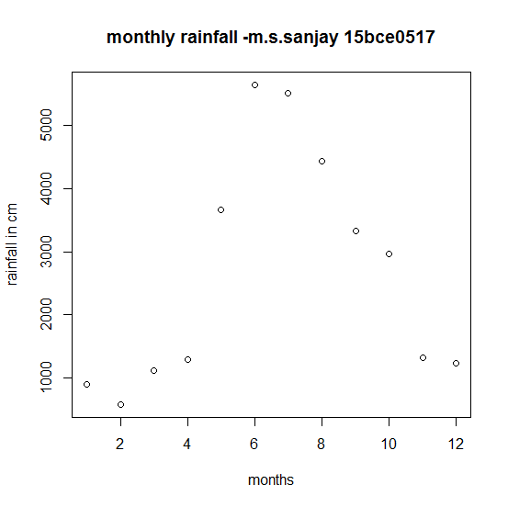

> boxplot(weather$MAX,weather$MIN,weather$RAIN,xlab="max temp, min temp, rainfall",main="box plot of max temp,min temp and rainfall-m.s.sanjay 15bce0517")

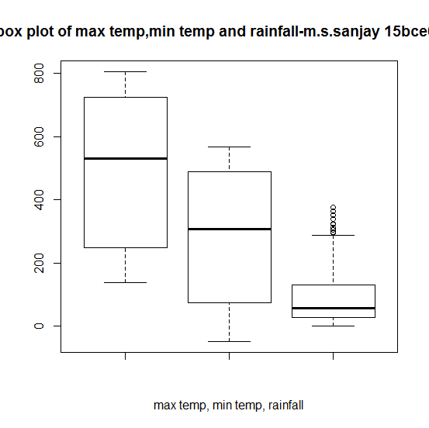

> hist(x,xlab="rainfall classes of range 1000",main="histogram of rainfall-m.s.sanjay 15bce0517")

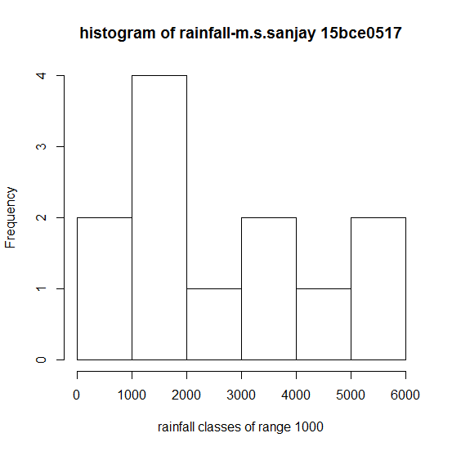

> plot(x,type="o",col="blue",xlab="months",ylab="rainfall in cm",main="line graph-m.s.sanjay 15bce0517")

